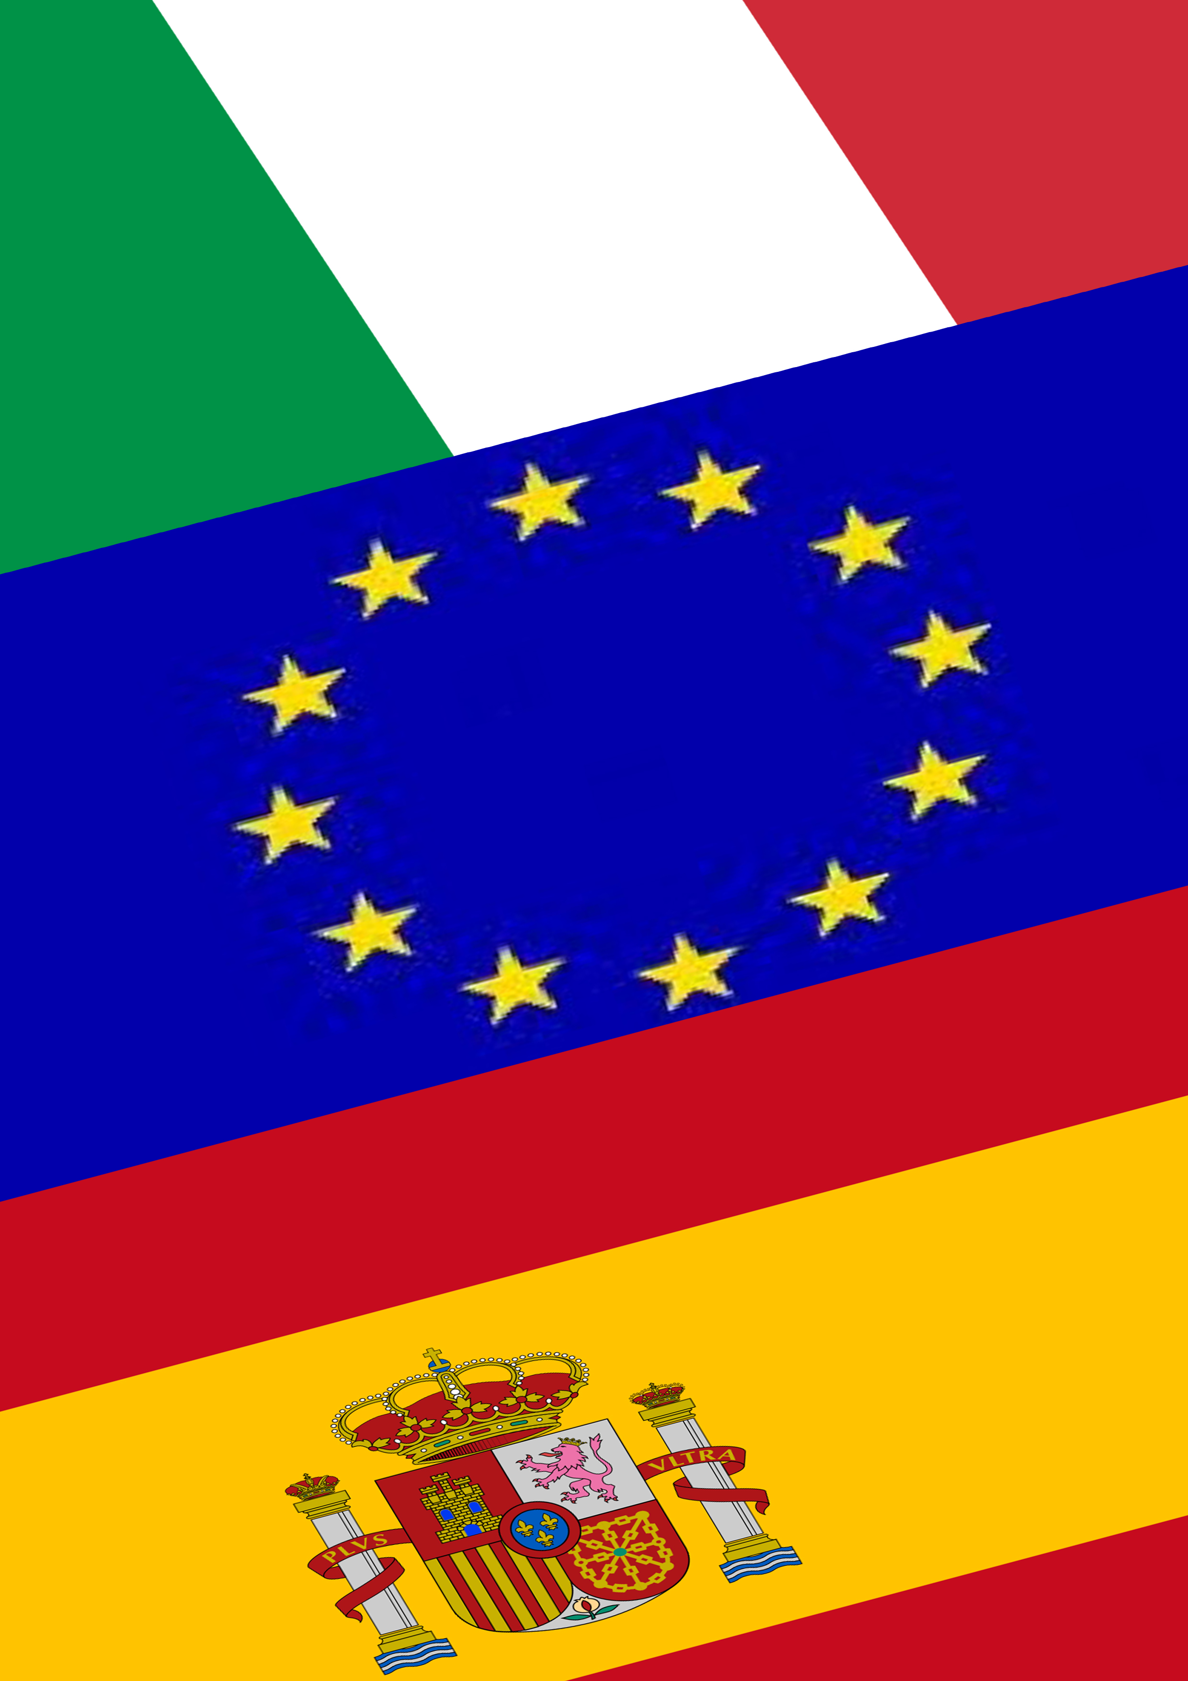­­­

­­­

**DIRECTOR OF ADMINISTRATION**

(SIMONA RUGGIERO e MARIA TEDESCO)

Accounting for purchases and sales, invoicing, financial statements.

**FINANCIAL DIRECTOR**

(MORENA MELISI)

Finding funds, maintaining financial balance.

**DIRECTOR OF SALES**

(MELISSA IULIUCCI)

Relationships with customers before and after sales, sales processing.

**MARKETING DIRECTOR**

(GIOVANNA VIOLA)

Product launch; actions for the sales facilitation.

**PURCHASING DIRECTORS**

(GABRIELE ESPOSITO)

Relationships with suppliers before or after purchase, purchase processing.

**COMMUNICATION DIRECTOR**

(MYKOLA BORUTSKYY)

Company presentation, information to customers and suppliers and to third parties.

**PRESIDENT**

(ALESSIA D’AGOSTINO)

Acknowledges the will of the shareholders meeting and traslates them into medium and long–tern plans; representation of the company.

**CEO**

(PASQUALINA MELISI)

Receives from the president or from the CDA or from the delegating partners on some specific functions.

**CONTROL ORGANS**

(LIN LONG SHENG)

Audit.

**GENERAL MANAGER**

(GIUSEPPE IANNUCCI)

Receives the decision of the higer organs, trasforms them into short-term directives and coordinates the other directions.