This is our catalogue, here you can find some typical food and some magnets of Naples.

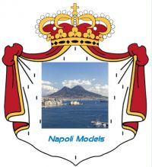
“ACCATTATV NU PENSIER P TENE’ NAPULE RINT O COR’”
“BUY SOMETHING TO KEEP NAPLES IN THE HEART”

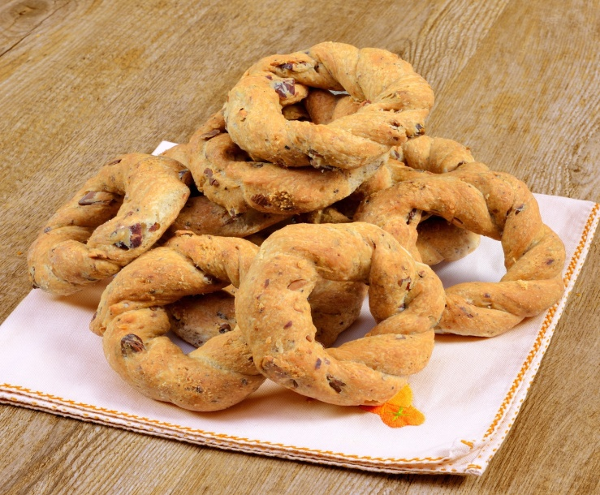 | TARALLI NAPOLETANI 300gr  (‘NZOGNA E PEPE)  The taralli ' nzogna and pepper in Naples have a history dating back to the late eighteenth century: it was at that time the bakers Neapolitans, to use scraps of bread dough advanced – and therefore with the yeast, unlike all other types of taralli – began to add pepper and pork fat.  Ingredients: flour, almonds with their skins, drough, salt and pepper.  Price: € 5,50  N. Identificative:1  Type: FOODS
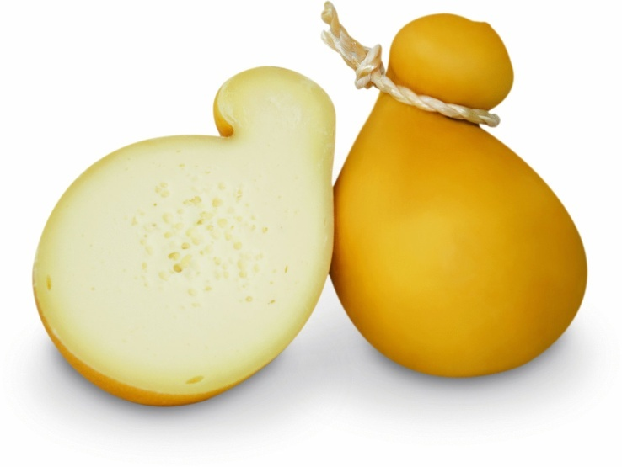 | CACIOCAVALLO 600gr  Caciocavallo is a type of  stretched-curd cheese made out of sheep's or cow's milk. It is produced throughout Southern Italy, particularly in the Apennine Mountains and in the Gargano peninsula. Shaped like a tear-drop, it is similar in taste to the aged Southern Italian Provolone cheese, with a hard edible rind.  Ingredients: Sheep’s or cow’s milk,  price: € 10  N.Identificative:2  Type: FOODS
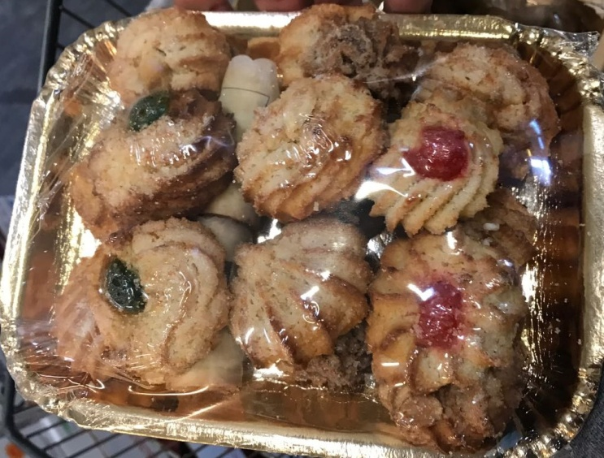 | NEAPOLITAN PASTRIES  Some of the special pastries of naples.  Ingredients: cream, cherry  Ingredients:flour, sugar, cream.  Price: € 5,00  N. Identificative:3  Type: FOODS
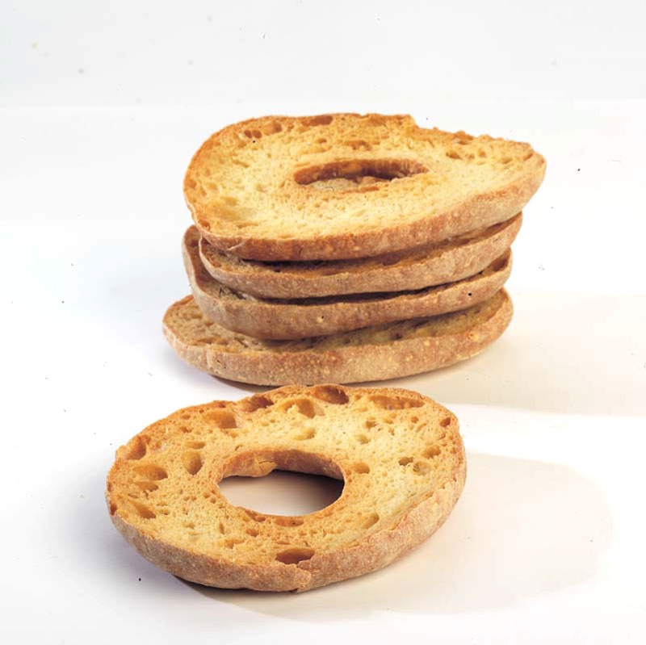 | FRISELLA 300gr  "Friselle" are a speciality of Southern Italy, they are salty and are usually accompanied by tomatoes and eaten with some oil on them.  Ingredients:flour, beer yeast, salt, water.  Price: € 4,50  N. Identificative:4  Type: FOODS
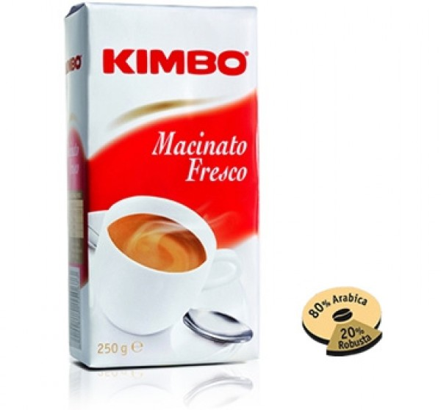 | CAFFÈ KIMBO 250 gr  (Coffee is an art that everyone is talking about)  ingredients: coffe  Price:€ 4,50  N. Identificative:5  Type: FOODS
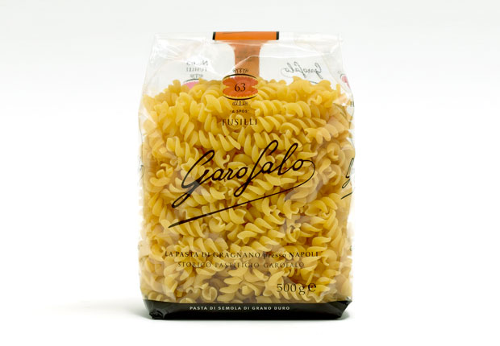 | PASTA GAROFALO 500gr  (fusilli a spos)  Making pasta is an ancient form of art, that involves history, culture, patience, secrets and traditions.  Ingredients: flour, eggs, salt, durum wheat semolina  Price: €3,00  N. Identificative:6  Type: FOODS

MAGNETS
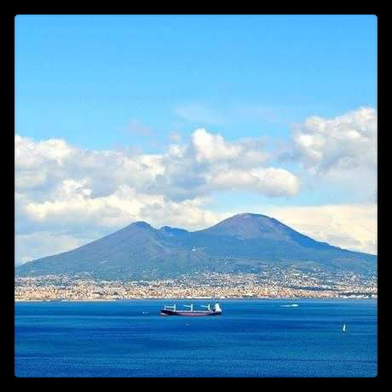
PLEBISCITO SQUARE
It’s 7cmx5cm magnets that represent the beautiful Plebiscito square.
Material:magnetized steel
Price: €2,50
N.Identidficative:8
Type:MAGNETS
GULF OF NAPLES MAGNETS
It’s 7cmx5cm magnets that represent the Gulf of Naples.
Material: magnetized steel
Price: € 2,50
N.Identificative:7
Type :MAGNETS

