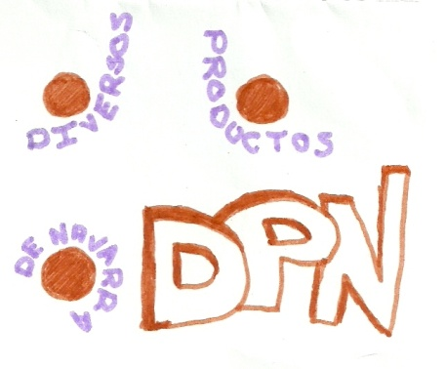
ORGANIGRAMA DIVERPRON

