Shampoo | Douchegel Perzik
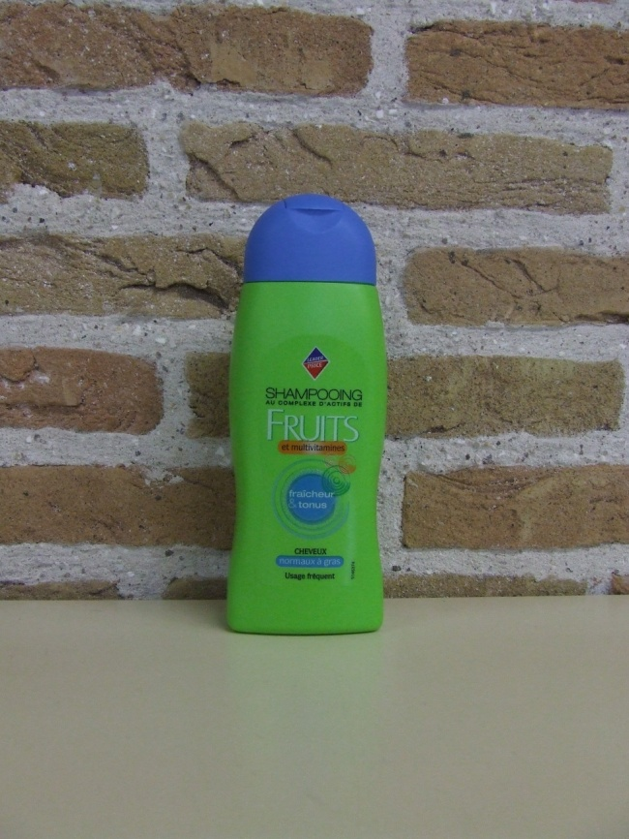 | 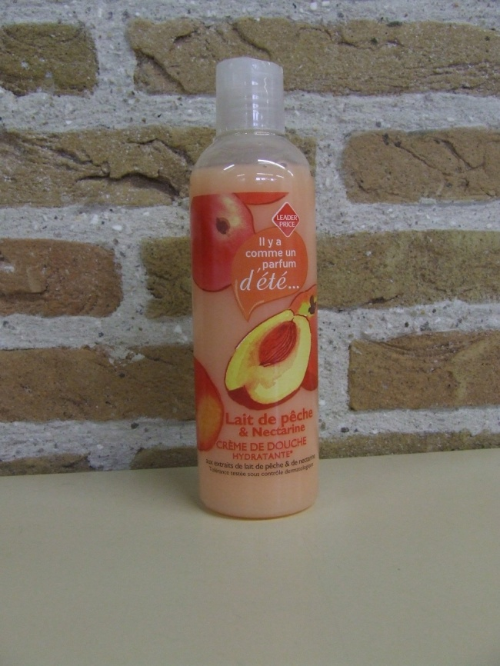
Weight: 300 g | Weight: 300 g
Content: 250 ml | Content: 250 ml

