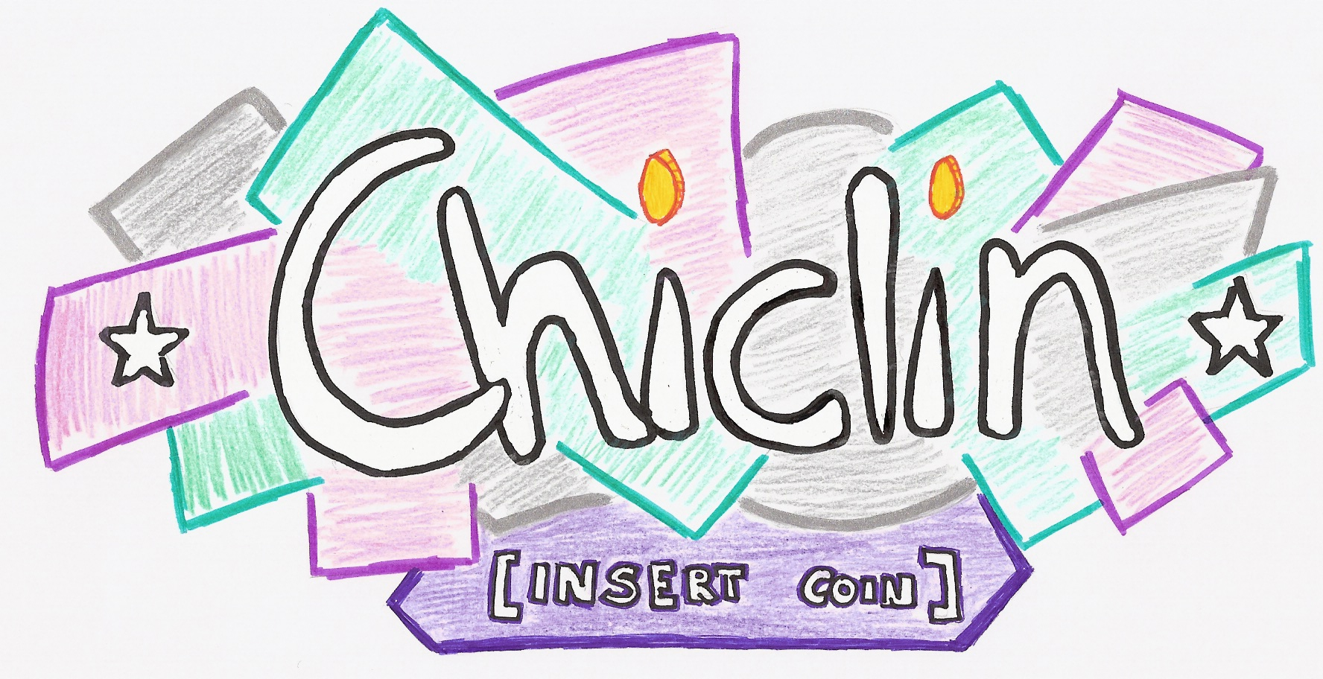

MEMORANDUM OF ASSOCIATION
OF
CHICLIN, S.COOP

CHAPTER 1
GENERAL PROVISIONS

Article 1: Company’s name
The company’s name is “Chiclin, S.Coop”

Article 2: Social Purpose
The company’s purpose is to buy and sell products.

Article 3: Length of the activity
The company will be considered active from September 22nd of 2009 until June 22nd of 2010.

Article 4: Registered office
The company’s registered office is to be situated in Oviedo (Principado de Asturias), C/Coronel Aranda, Nº 5.

CHAPTER 2
MEMBER´S RIGHTS AND OBLIGATIONS

Article 5: Member’s rights
Members are entitled to the following rights:

- To take part in the co-operative corporate purpose.
- To take part in the elections, and be eligible for company positions.
- To participate, with voice and vote, in any agreements reached at the General Assembly and other company bodies to which members may belong to.
- To obtain information on any aspect concerning the progress of the co-operative.
- To be entitled to participate of the surplus, in proportion with the work developed in the co-operative.

Article 6: Member’s obligations
Members are the following obligations:

- To attend General Assembly meetings
- To comply with decision made democratically in the co-operative.
- To accept company positions for which one is elected and assume the relevant responsibilities.
- To participate in all company activities.

CHAPTER 3
CAPITAL

Article 7: Share capital
The co-operative’s share capital comprises all the contributions made by the members.
In order to become a member, each person must contribute 13 €.

Once members have paid their fees, they will receive a document certifying they are members. The ownership of the share cannot be transferred.



